# ADAPT: An Algorithms Database for Arbitrary Parameterized Topologies

# Jorge Canedo

# Assignment 2 6/9/20

For this assignment, you will describe and implement release 1 of your term project. You will incorporate *divide and conquer*. You are free to choose a project that interests you but if you prefer, I will be happy to suggest a topic. If you are already experienced with algorithms, this is an opportunity to build a challenging application or discuss research with me. It is fine to choose a project with much more scope than you can hope to accomplish in the course: we will not hold you to completing everything associated with it. What we do expect is that you specify and implement a set of do-able requirements within such scope, which you will supply.

Submit this completed Word document, replacing all parts “Replace this …”, observing and retaining the gray text. Your materials—in black 12-point Times New Roman—should not exceed 5 pages excluding references, figures, and appendices. Use the Appendix sections for additional material if you need to. These will be read only on an as-needed basis.

## 1.1 SUMMARY DESCRIPTION

One- or two-paragraph overall description of your proposed term project—half-page (12-point Times New Roman) limit. By the end, term projects will incorporate most of the topics discussed in the course—so read ahead get a feel for what’s to come. To do this, you may need to alter the direction of your project or introduce an additional project. You may alter this or even replace it as the semester progresses. You will probably find it useful to use your project acronym.

This project concerns a database of files that are used to generate a parameterized tiling object and perform rudimentary algorithms on these tilings in an efficient manner.

## 1.2 PROJECTED I/O EXAMPLE FROM PROJECTED COMPLETED PROJECT

Provide an example of projected *concrete* output for designated input. You will not be held to fulfilling exactly this—it is just explanatory at this point, to indicate where your project is going. We recognize that project direction and details will change as the term progress. This section refers to the project as a whole, not just to what you will produce this week, so we can gain an idea of what you have in mind overall.

This project has no explicit goal, rather it will act as a collection of algorithms. Optimally, one would be able to create one of several objects and perform algorithms such as greedy, search/traversal, multithreading, and more. These algorithms will be implemented in conjunction with a repository (created entirely, and I do mean entirely, by me), and will not alter the repository files that will likely evolve over the course of the class by its own accord.

Rather my class project will be able to create instances of tiling algorithms and do things like Dijkstra’s algorithm. Due to the scale of the project, there is ample place to add all kinds of algorithms and I think the difficulty will really be choosing what do apply each algorithm to,

## 1.3 REQUIREMENTS IMPLEMENTED IN THIS RELEASE

Supply [functional requirements](https://docs.google.com/document/d/1eU7eINLDxmrf793D4OF2yGT4ry_SW3GQGoVDYzecGHc/edit?usp=sharing) statement that you accomplished for this assignment, together with input where applicable, and output. Please try to state requirement in declarative form, as illustrated in the examples, because here we want to know the functionality intended (*what*, not *how*). The example material should be deleted. Keep in mind that the implementation of these requirements will incorporate *divide and conquer*, and that will probably influence the requirements you choose to implement in this assignment.

### 1.3.1 Convert MultigridList Data

The QuadTree constructor should convert parameterized MultigridList data into a more usable valued 2d grid-array.

### 1.3.2 Create QuadTree

The QuadTree constructor should create a correct quadTree representation of the valued grid calculated in 1.3.1. For a representation of how divide the divide in divide and conquer acts on a valued map, please see Appendix 1

### 1.3.3 Print The QuadTree

The QuadTree class can then efficiently traverse each unique canonicalized leaf of the quadTree and print useful information such as values or object ids. This acts as the conquer part of the algorithm.

## 1.4 ILLUSTRATIVE OUTPUT

### Provide illustrative output from your application showing that the requirements have been met. Explain what class.method(s) produce it.

The following is produced by *QuadTree.printQuadTreeNodes(QuadTree.rootNode)*

*Lets suppose that QuadTree.convertToQuadTree() acts on the following valued map:*

*valMap0 = [[1 1 1 0], valMap1 = [[1 1 1 1],*

*[1 1 0 1], [1 1 1 1],*

*[1 1 1 1],*  *[1 1 1 1],*

*[1 1 1 1]]*  *[1 1 1 1],*

=========The outputs for valMap0 and valMap1 respectively==========

Val=1, size=2 Val=1, size=4

Val=1, size=1

Val=0, size=1

Val=1, size=1

Val=0, size=1

Val=1, size=2

Val=1, size=2

## 1.5 MY DIRECTORY

In the above picture I have subdivided the repository into two parts. The left half contains a README.md script and four folders. ‘MultigridListData’ acts as a selective folder where tiling automata instances that display complex behavior for more than maxGen generations are stored, the rest are stored in ‘TrashLists’. The ‘Example’ folder contains animated examples of the outputs from MultigridList.py on the right side, ‘About The Method’ contains some examples of the general tiling space, a projective function example and a short mathematical description of the repository this was built off of called PenroseTiling which I also built myself.

The right side contains on the top row, the three scripts needed to create an animation: ‘MultigridLIst.py’ is responsible for animating and contains a collection of Multigrid objects from ‘Multigrid.py’ which is itself a collection of MultigridCell objects from ‘MultigridCell.py’. The second row contains ‘QuadTree.py’ which will be the main script for this first assignment on divide and conquer. The ‘__pycache__’ folder stores misc. runtime information in IO.

## 1.6 DIVIDE AND CONQUER IMPLEMENTED BY QuadTree

### 1.6.1 QuadTree Construction and Printing

### Identify where you included *divide and conquer.* To do this use tools (e.g., Visio), PowerPoint, or a combine models as in [this example](https://docs.google.com/spreadsheets/d/1vBmDVtWWh3EX0oehFFLRU0P6eR-fn4d0qVg1-XOUooM/edit?usp=sharing) (which you are free to cut and paste from). Insert indications in red (as in [this example](https://docs.google.com/spreadsheets/d/1ZvkerE9FkWHWwVGdzuy7YMBU6oBMFGZbA4sotFETs8Y/edit?usp=sharing)) to show where the three features below apply.

Divide and conquer is used for two purposes in QuadTree. Primarily, it is used by makeQuadTree() to convert a grid into a tree of sub quadrants, by means of a recursive algorithm. Unless the grid meets a stopping criterion, we recursively call subdivideGrid() on the four sub quadrants. Second, we also use divide and conquer to traverse the nodes of this tree and print the values of each node and the id of the object to insure proper canonicalization of equal nodes. For a visualization of this process, please see Appendix A

### 1.6.2 Code showing divide and conquer.

Screenshot one concerns the primary recursive method subdivideGrid(), which makes use of it’s helper makeNode() in screenshot two. Note that subdivideGrid() is first called from makeQuadTree() in the third screenshot, which itself is called from the QuadTree constructor instantiated in line 220 in screenshot three and implemented elsewhere. SubdivideGrid() is fairly straightforward, the duty of checking whether a node has been seen before and then properly creating a QuadNode is subjugated to the makeNode() helper. subdivideGrid() simply deconstructs the valued map into its square minimal units subcomponents and makeNode() does the heavy lifting work of checking whether all the values are within a bound and whether all grid can be canonicalized.

In screenshot three, printQuadTree() also uses divide and conquer, here it can be plainly seen that we recursively call each sub-quadrant by dividing the grid into smaller uniform leaves, printing information out if specified. While this printing algorithm could be more efficient and more traditionally ‘divide and conquer’-y, we could have directly saved the leaf nodes and combined them recursively on the way up. But as I soon discovered, to verify the quadTree is constructed properly, we must be able to print out the whole tree. Thus we save every recursive deconstructive act to the quadTree tree data struct so we can easily access any part of the tree later for verification.

Show the relevant code (only) and explain why divide and conquer is appropriate here. It should be clear where the code is located (class and method).

## 1.7 YOUR CODE

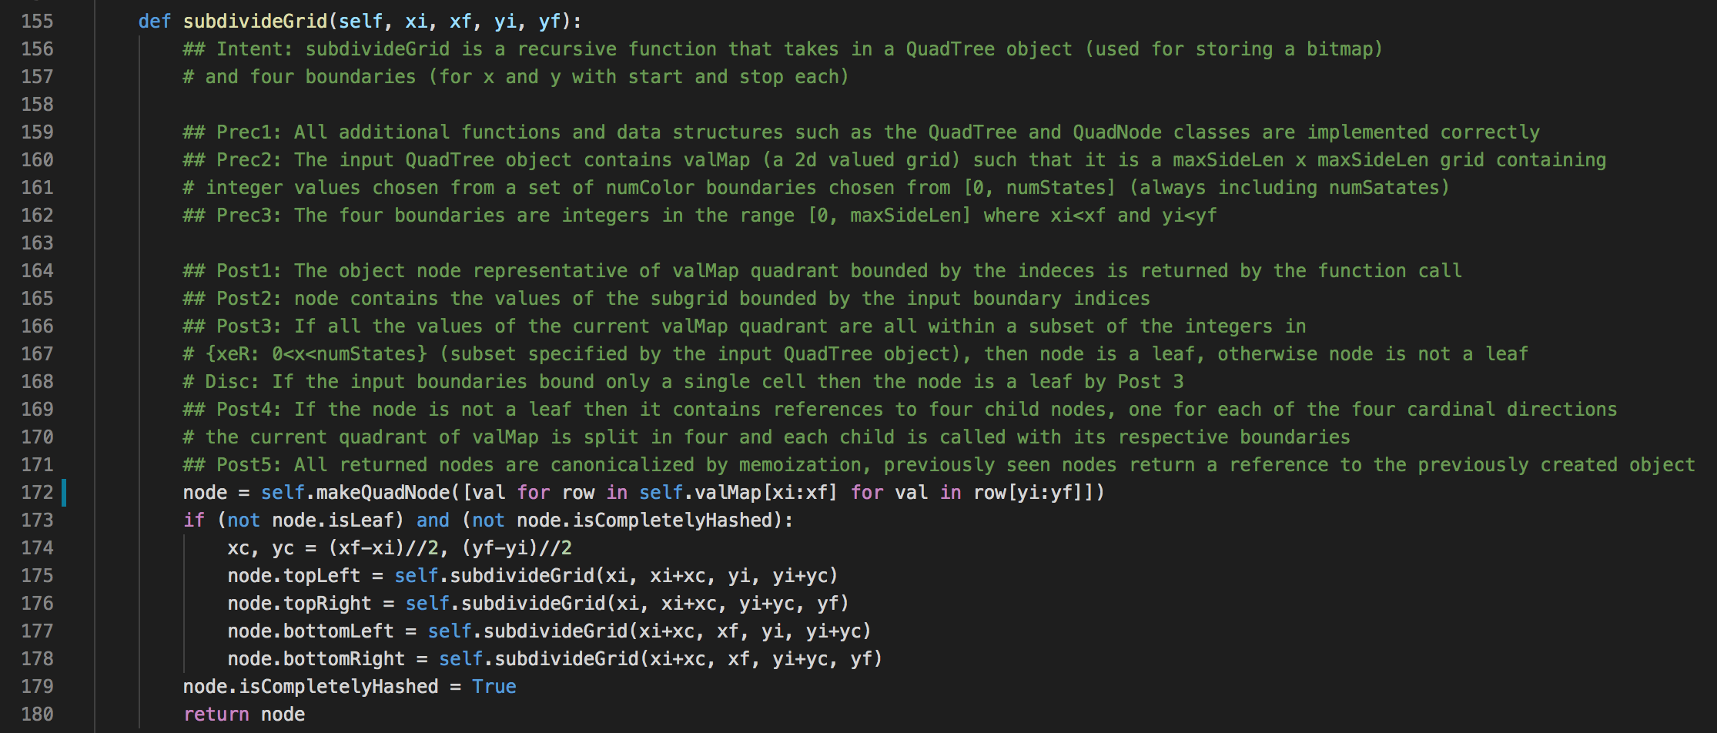

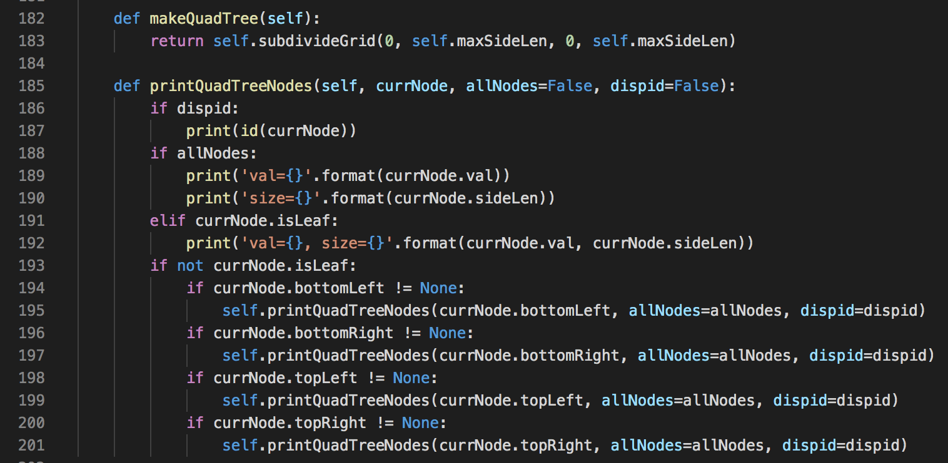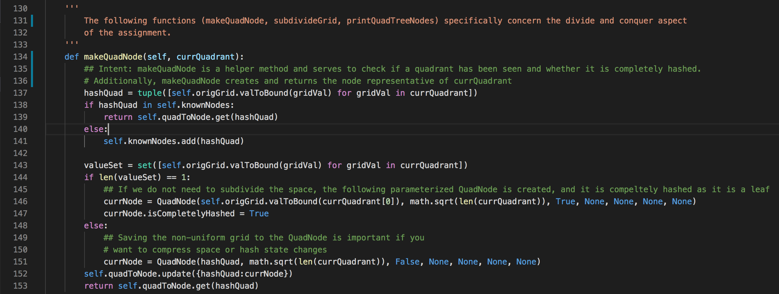

Unless your facilitator requests another method, copy your Eclipse project to your file system, zip it, and attach it. Please contact your facilitator in advance if you want to request an alternative means.

https://github.com/jcanedo279/PenroseAutomata

## 1.8 Instructor’s Evaluation

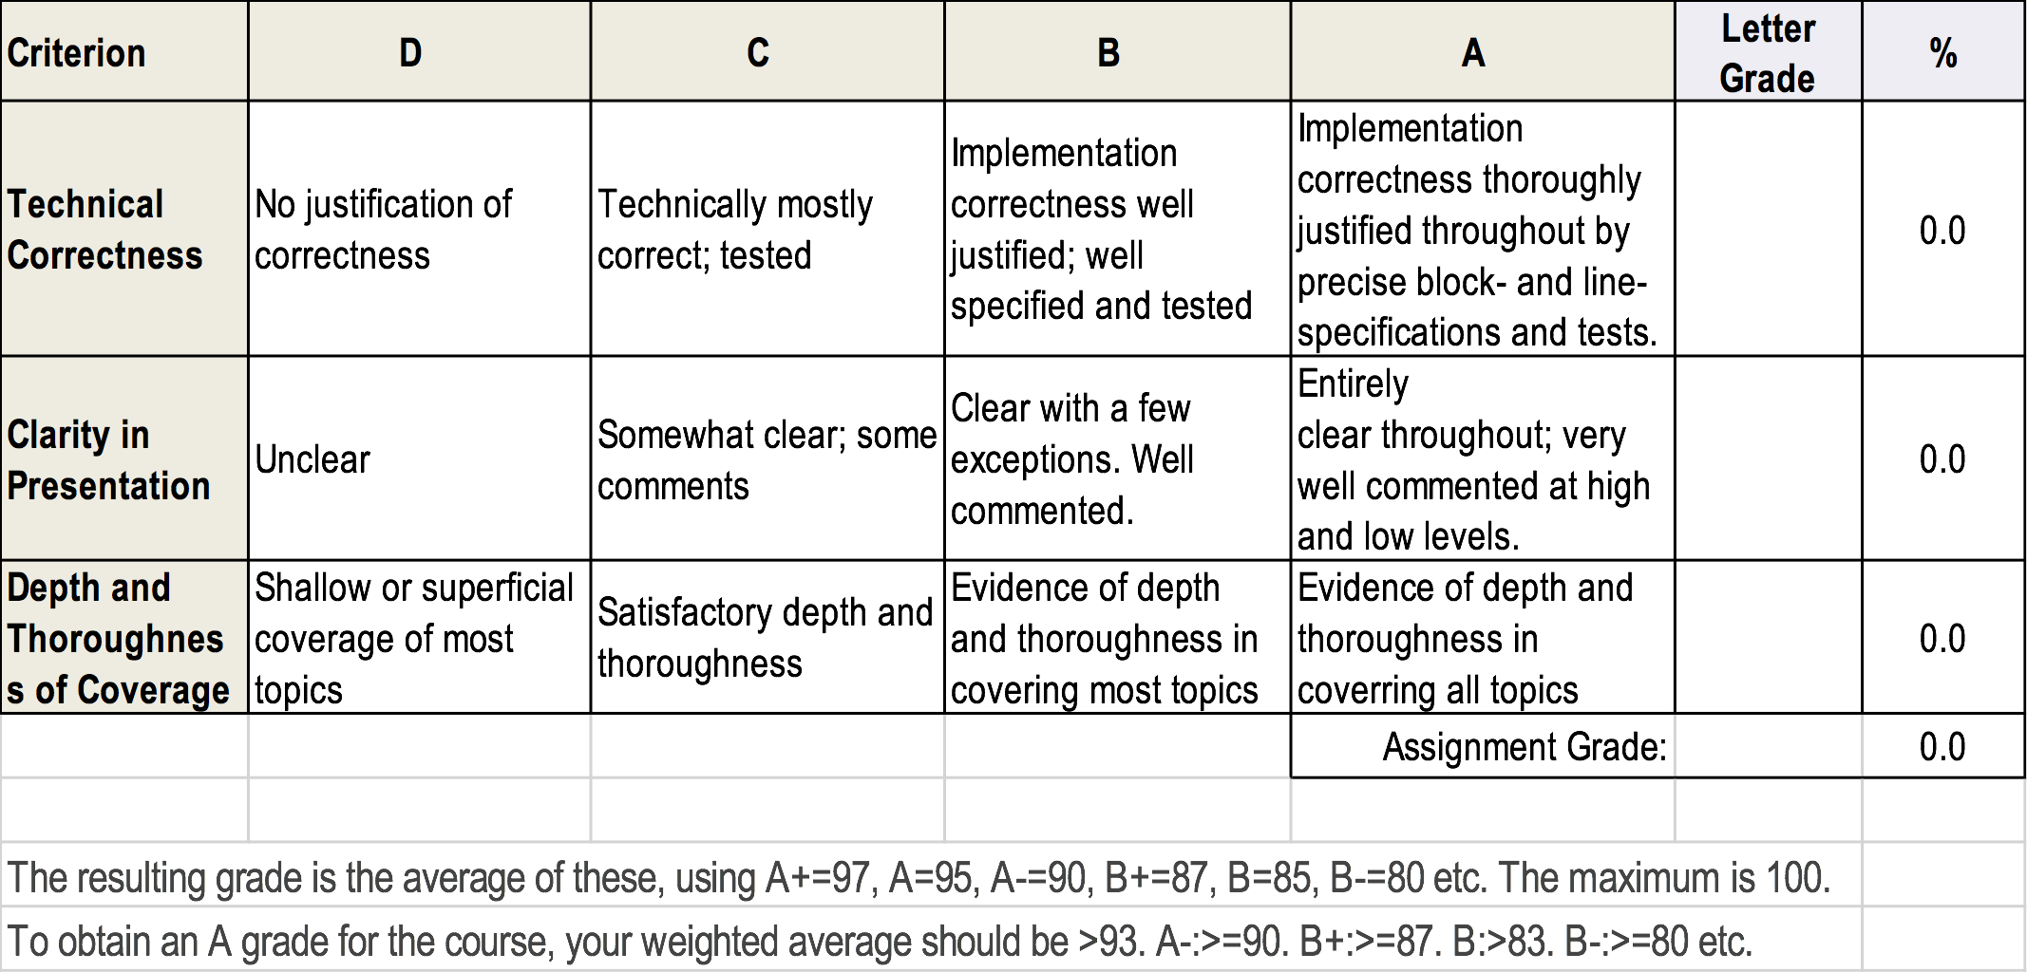

## Appendix 1

The following is an example of what makeTree would produce, namely a canonicalized Quad Tree